K2 G Suite Add-on

Development and Installation

GitHub Repository: <https://github.com/k2workflow/G-Suite-Add-on>

# Development Environment

Google provides Clasp which is a Visual Studio Code extension that allows for easier authoring and management of your Apps Scripts than their online tooling.

* Install and configure Visual Studio Code <https://code.visualstudio.com/>
* Install and configure Clasp per the project documentation <https://github.com/google/clasp>
  + Please note that this also contains a user setting in google.

# Project Setup

The following steps are necessary to get an existing project into a new environment and wired up for development and testing.

## Setup GCP Project

* Navigate to GCP Resource Manager <https://console.cloud.google.com/cloud-resource-manager>
* Select Create Project
* Name: K2 G Suite Add-on
* View details and copy the **Project number** value

## Setup OAuth Consent

* Navigate to <https://console.cloud.google.com/apis/credentials/consent>
* Select User Type: Internal and Create the OAuth consent
* Application Name: K2 G Suite Add-on
* Application Logo: {Upload k2_logo.png}
* Accept defaults and Save

## Setup Apps Script Project

* Navigate to Apps Scripts <https://script.google.com/home/my>
* Select New project
* Name: K2 G Suite Add-on
* Link the Apps Script and GCP Projects
  + Resources > Cloud Platform project…
  + Paste the Project number value from GCP project here, select Set Project, and close when successful
* View File > Project Properties and copy the **Script ID** for VS Code

## Setup VS Code Project

* Download files from repository and open in Code
* Edit .clasp.json file and paste the Script ID as the scriptId value
* Save all files and open terminal
* Login to Google via clasp

clasp login

* Update the project with the local files

clasp push

## Test the Add-on

* Navigate to Apps Scripts project <https://script.google.com/home/my>
* Publish > Deploy from manifest…
* Click Install add-on
* Open Google Drive or Gmail and click on the K2 icon in the Add-on bar
* Authorize Access

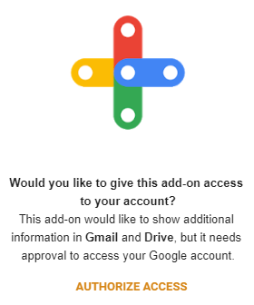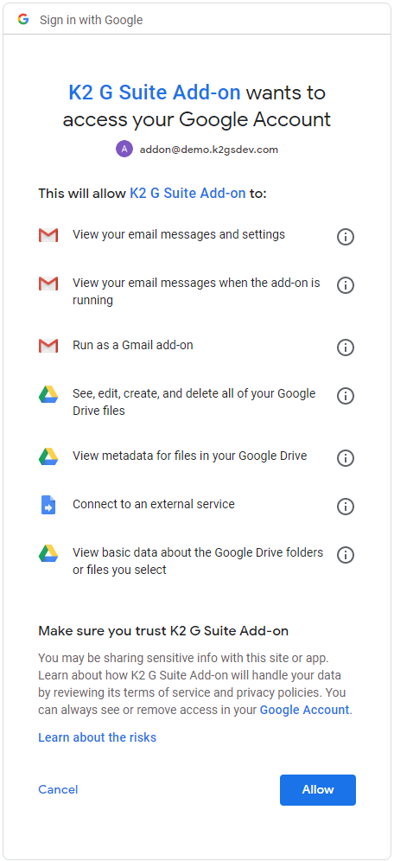

The K2 G Suite Add-on has now been installed and can be tested. Changes to code can now be made in either Apps Script or VS Code and synced using Clasp and re-deployed using the same mechanism for testing. Most changes can be tested by simply refreshing the add-on but ‘structural’ changes, such as authentication, require full uninstall/reinstall to test. Apps Script tools can be used to enhance debugging.

# Domain Publishing

G Suite Add-ons can be shared with others by publishing via the G Suite marketplace for either public or private/domain access. This will describe the process for publishing for domain access.

## Create Deployment

* Navigate to Apps Scripts project <https://script.google.com/home/my>
* Publish > Deploy from manifest…
* Deployments: Create
* Deployment name: Initial Deployment 2020-06-25
* Manifest: appscript
* Version: New, Initial Release 0.1
* Manifest entrypoints: gmail add-on
* Click Save and then click Get Id and copy the **Deployment ID**

## Enable G Suite Marketplace SDK

* Navigate to <https://console.developers.google.com/apis/library>
* Search for and enable G Suite Marketplace SDK

## Manage G Suite Marketplace SDK

* Navigate to <https://console.cloud.google.com/apis/api/appsmarket-component.googleapis.com/overview>

### Configuration

* Select Configuration
* Application info
  + Application name: K2 G Suite Add-on
  + Application description: K2 G Suite Add-on for K2 workflow APIs
  + Enable individual install: checked
* Application icons
  + Select the associated sized logos
* OAuth 2.0 Scopes

|  |
| --- |
| https://www.googleapis.com/auth/userinfo.email  https://www.googleapis.com/auth/userinfo.profile  https://www.googleapis.com/auth/script.external_request  https://www.googleapis.com/auth/drive  https://www.googleapis.com/auth/drive.metadata.readonly  https://www.googleapis.com/auth/drive.addons.metadata.readonly  https://www.googleapis.com/auth/gmail.readonly  https://www.googleapis.com/auth/gmail.addons.execute  https://www.googleapis.com/auth/gmail.addons.current.message.readonly |

* Support URLs
  + Terms of service URL: <https://github.com/k2workflow/K2-G-Suite-Add-on>
* Extensions
  + G Suite Add-ons Extensio
  + Paste Apps Script project **Deployment ID**
  + NOTE: Gmail Add-ons Extension and Drive Add-ons extensions should be auto selected
* Visibility
  + Select My Domain (Only available to users at *{your domain}*)

### Publish

* Select Publish
* Detailed description
  + Application detailed description: K2 G Suite Add-on for K2 workflow APIs
* Banner (220x140): TODO
* Screenshot (640x400): TODO
* Developer website: <https://github.com/k2workflow/K2-G-Suite-Add-on>
* Developer name: K2
* Category: Office Applications
* Success toast will show App URL very quickly and is not clickable.

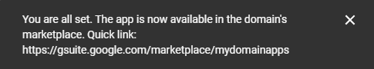

* Don’t worry, you can now see the App URL at the top of the Publish page.

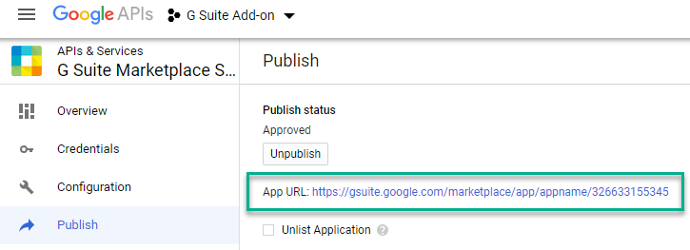

* Select to Domain or Individual Install and consent to the app

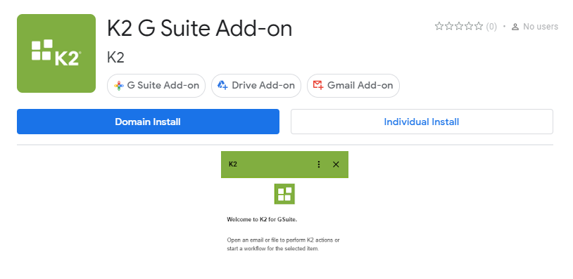

* Consent to the App and you will see a success confirmation

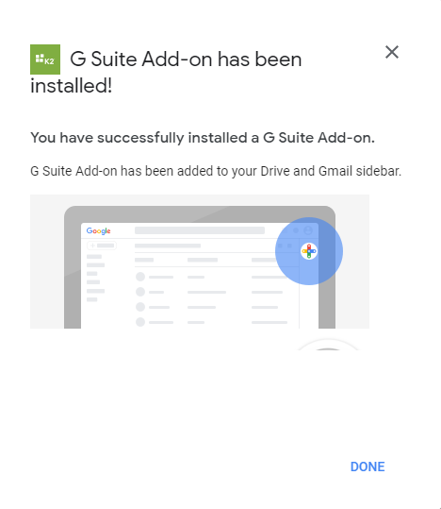

* Navigate to Drive or Gmail and the App will now be available via the Add-on bar

